Class Diagram For 5 Applications

1.Hotel Management system
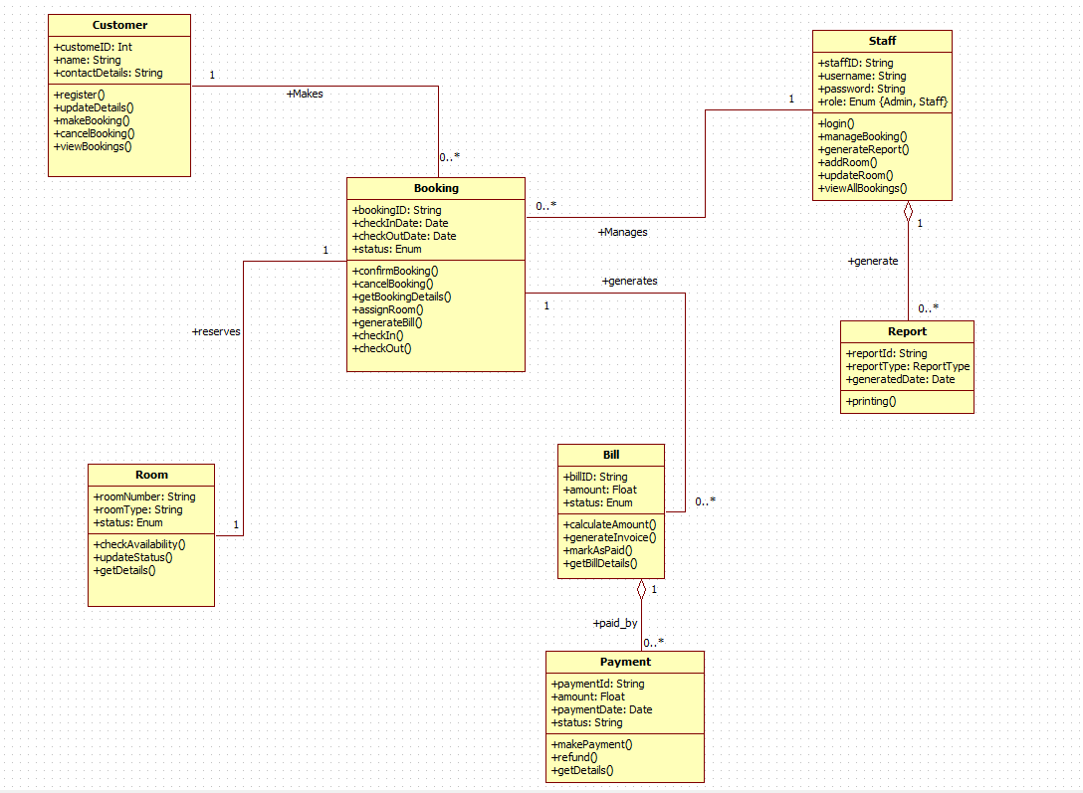

2.Credit Card Processing
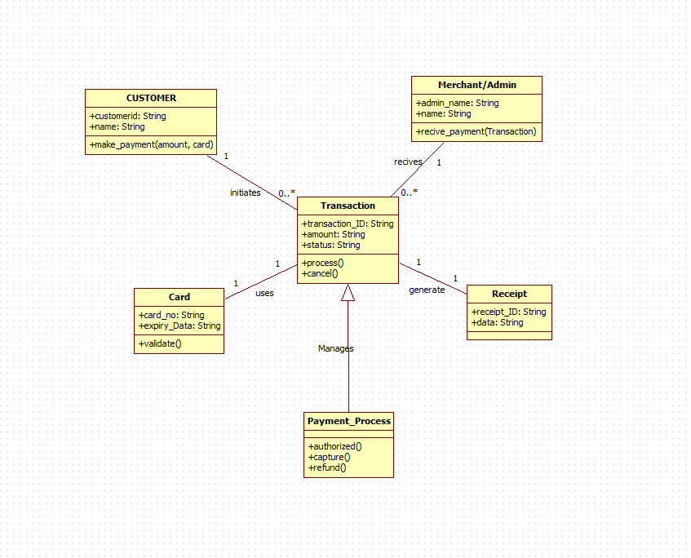

4.Stock Maintenance System
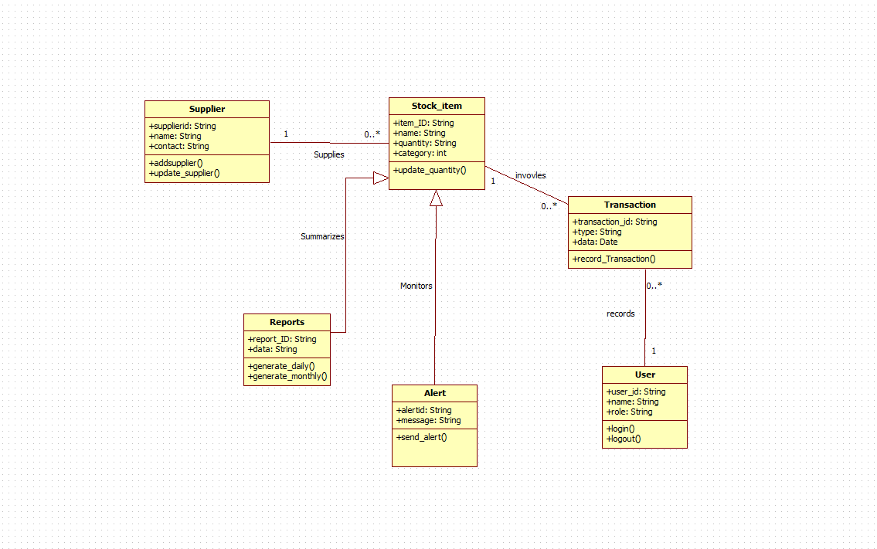
5.Passport Automation System
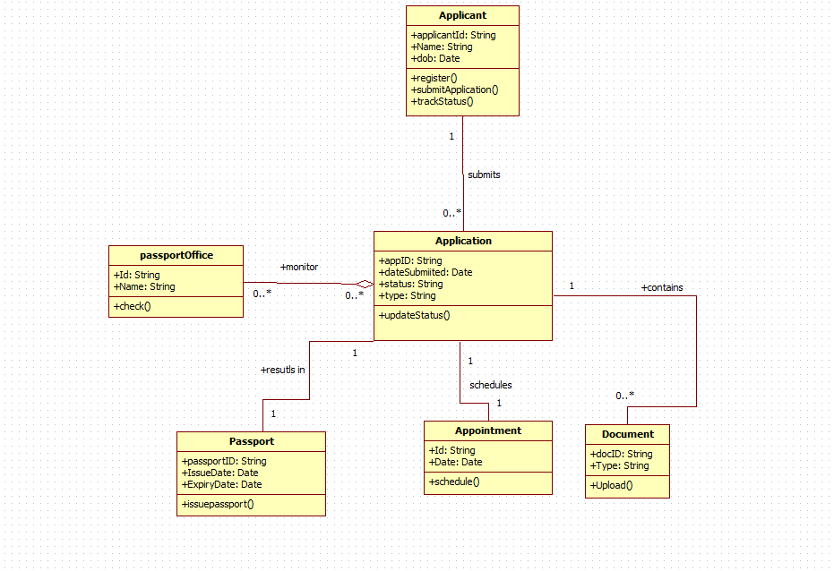
3.Library Management System

